ITI Program - HTML Report

Name: Mohamed Ahmed Ezzat

  - 1.Introduction
This report shows the concepts and the fundamentals that I’ve gained during my first week of learning about Hyper Text Markup Language (HTML).

  - 2.Core and fundamentals of HTML
In the first day we learned about the internet and how the history works and some deep details about its history, we also learned about the basics tags that’s used in HTML
- We learned that Tim Berners Lee is the man who came up with this technology and made the World Wide Web in 1989, before it was only used by the USA Defense Department.

- We learned the difference between the static and dynamic pages and how they work and the three web designs which are (Static, Dynamic and Responsive)

- We also learned about the opening and closing tags and different attributes in addition to the difference between Block Element and In-Line Element, there are some elements that are originally a Block like (div), and some are In-Line like the (span)

- We learned about the semantic HTML and understood why we use them, and these are some of the sections ( <header>, <main>,<footer>,<nav>,<articler> )

- We learned a lot of important tags that’s essential when first starting to learn HTML, and here are some of them, first the heading tags ( <h1> to <h6> ), ordered and unordered lists ( <un> <li></li></un>, the Blockquote (<blockquote>), and some text formatting like the <i> , <b> and the difference between them and the <strong> and <em>, and finally we learned about the <fieldset> and the <legen> and how to use them when we are making a form.

  - 3.Basics of how to use Intermediate HTML
In this section we learned a lot more about HTML and we were taught how to use attributes to control different tags.
- We learned about the DOM and the HTML structure using the semantic elements, which are <header>, <nav>, <main>, <article>, <section>, <figure>, <footer>.

- We knew that the Block elements when they are created they own their whole line of page and the other block has to go below it like ( <div>, <p>, <ul> ), while In-Line allows other elements on the same exact line like ( <a>, <img>, <span>)

- We learned how to organize the data using tables ( (<table> , (<thead>, <th>), (<tbody>,<td>),((<tfoot>,<td>)), we learned how to adjust them using ( align, colspan, rowspan, width, height)

  - 4.Complex and Advanced HTML
On this day we started learning more advanced HTML and we did a lot of activities which made me feel comfortable having my hands on coding with HTML
- We learned about forms, inputs, and some of its attributes. We used the <fieldset> inside the <form> to make the form look more clean and organized, we used a lot of inputs and we used the attribute (type=””) to decide its purpose, and here are some of the inputs we used (“text”, “email”, “radio”, “checkbox”, “date”, “button”) along with some attributes like(placeholder, required, autofocus, readonly, delete), we also learned about making (list using input) and (datalist and list), and some of its tags like (<options> which gives the options in the select, and <optgroup> to organize the select), and we learned about the <textarea> and how to limit its length by using the attribute (maxlength=””).

- We learned about how to insert media into our website & we learned about the Meta tags, we used ( <img src=”” alt””> to put the path of the img and its alternate if corrupted),we also used (<audio>,<video> and used attribute like controls width and height). We also covered the meta tags and that its for the page data and the user cant see this since its in the head tag <head>, we finally learned about the <link> and how to connect it to out css style sheet and <script> for code.

  - 5.Practical Projects Using HTML
We made few projects thanks to this program and the instructor there was not any difficulties having these projects done, and one of them was a portfolio project.
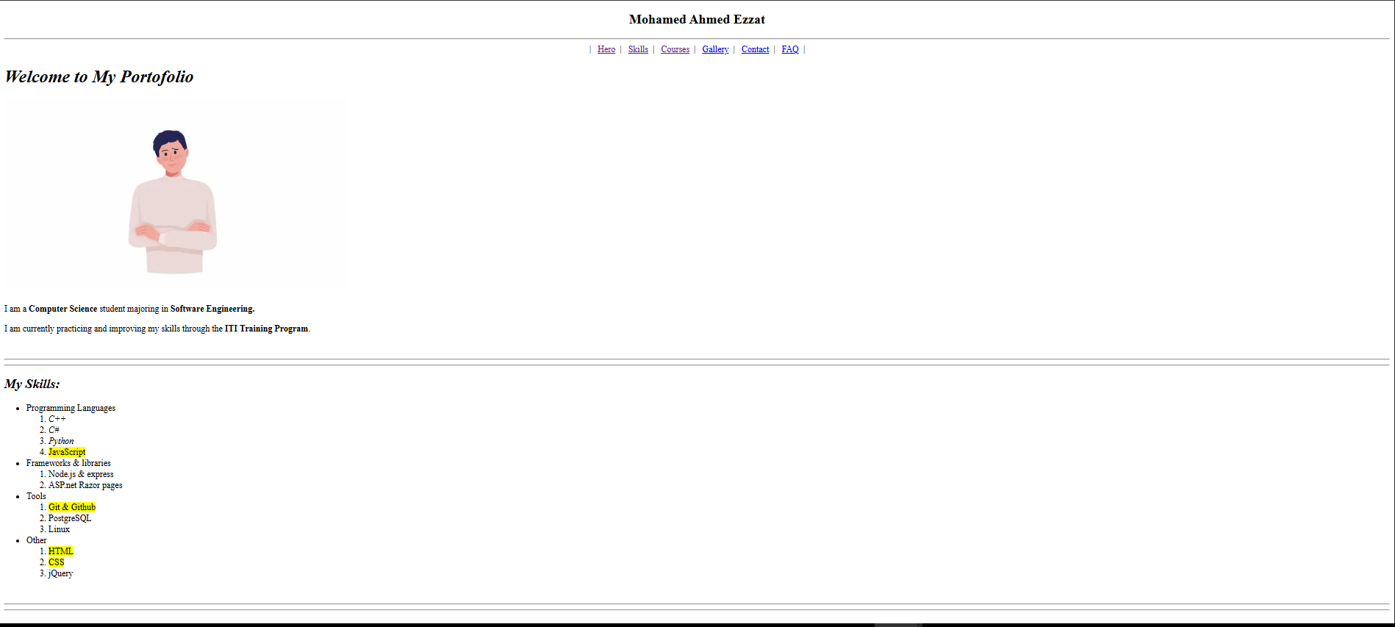
- First I made this simple <nav> by using <a> and linking it to every semantic sections id(id=””) and I used the entity (&nbsb;) to create some space between each pipeline. I wrote my name using <em> with a <h1> heading, and used <hr> and <br> to use some styling since it’s a raw HTML code, I used <img> to put my image on the website and <p> to write some info about me and some bold <b> to important infos

- To create the skills section i used unordered list <ul> nested with <ol>, and I marked the contents in the program using <mark>
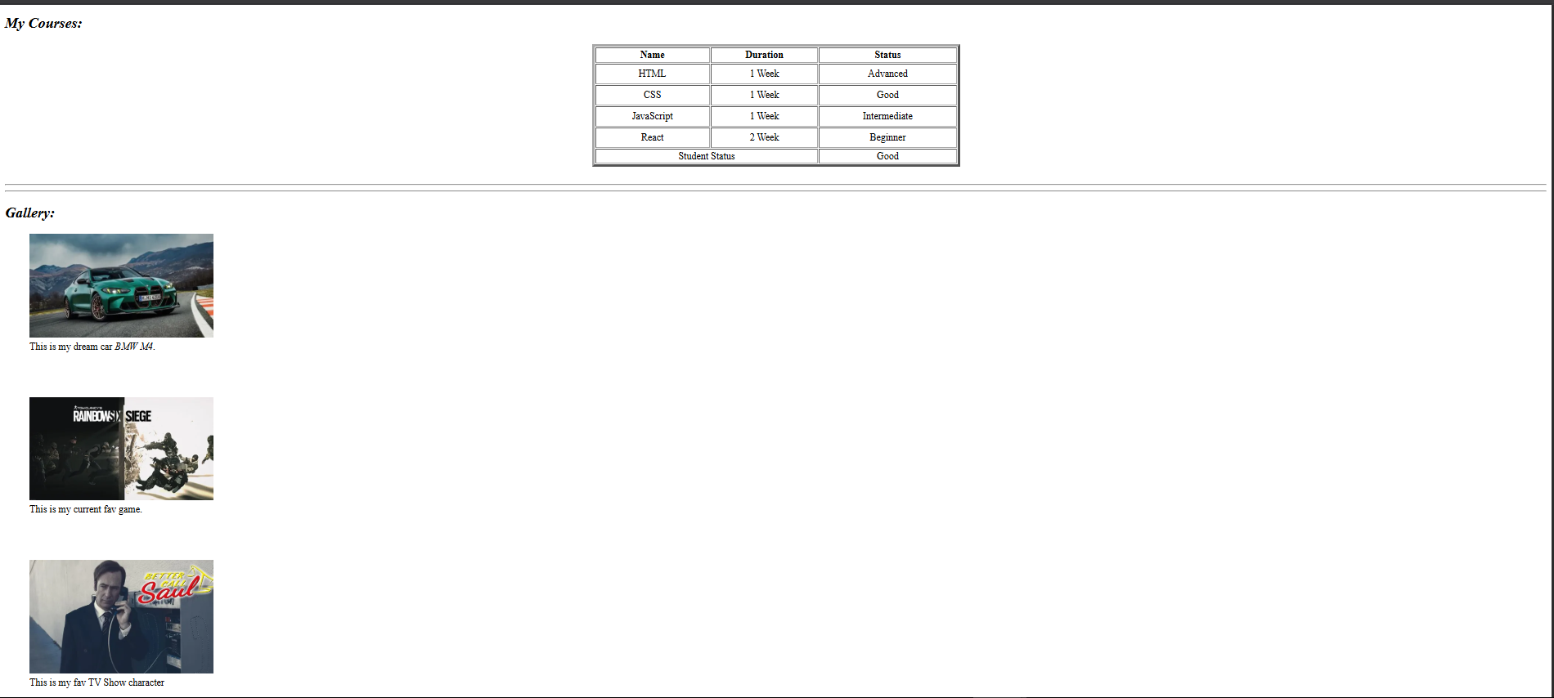
3.I made this simple courses distribution using a table with all its elements <thead> for the titles using <th>, and then i used the <tbody> to put my data, then used the <tfoot> with an attribute colspan=”2” to take the empty left col in the footer as we only got 2 datas in the footer.

4. In the gallery section I used the <figure> element and <figcaption> to have this clean look with the caption under the image, I created the image using the <img src=”” alt””>
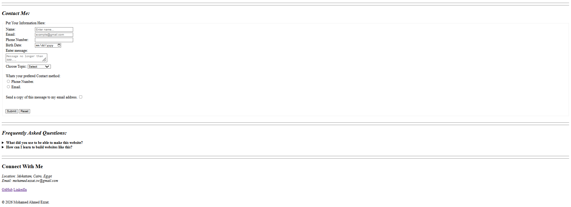
5.In the contact section I used a lot of input types which are (“text”, “email”, “tel”, “date”,”checkbox”, “radio”) I used (<textarea>) for the message, I used <select> and its elements <options>,<optgroup> to make the select bar, and I used the <button> element with two types which are ( submit, reset ).

6.Finally the FAQ and Footer sections, I used semantic element <summary> and its element <details> to make this interactive look and then I made the semantic footer element and and I used <address> to put my address, and I linked some of my socials using <a href”Link Here”> and finally the copy right entity using (&copy;).

  - 6.Conclusion
This first week of the ITI program has helped me a lot in learning more about HTML and building strong foundation in the web development. Now I understand how to use HTML to build the structure of the website using the semantic tags, forms, tables, and a lot more. I am excited to procced to the next level and I’m confidently ready to learn about the different sections of this program which are CSS, JS and React.

